Module 5 assignment :
Create a Bash script 'file_analyzer.sh', to demonstrate the following concepts: 1. Recursive functions - Write a recursive function to search for files in a directory and its subdirectories containing a specific keyword.

2. Redirection and error handling - Log errors (e.g., invalid arguments, missing files) to 'errors.log' and display them in the terminal.

3. Here document and here string - Use a here document to display a help menu when the '--help' option is passed. - Search for a keyword in a specified file using a here string
4. Special parameters - Use parameters like '$0', '$#', '$?' and '$@' to provide meaningful feedback.
5. Regular expressions - Validate inputs with regular expressions (Check if the file exists and the keyword is not empty and valid)6. Command-line arguments using getopts - Use 'getopts' to handle: '-d <directory>': Directory to search. '-k <keyword>': Keyword to search. '-f <file>': File to search directly. '--help': Display the help menu.

Q1)

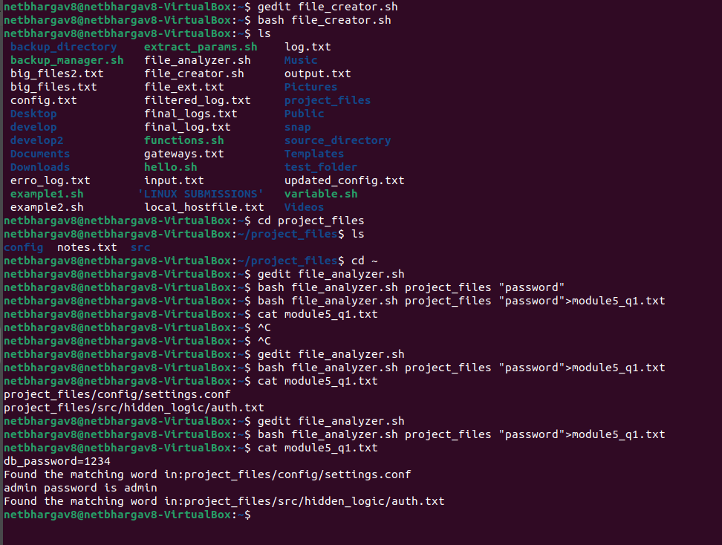

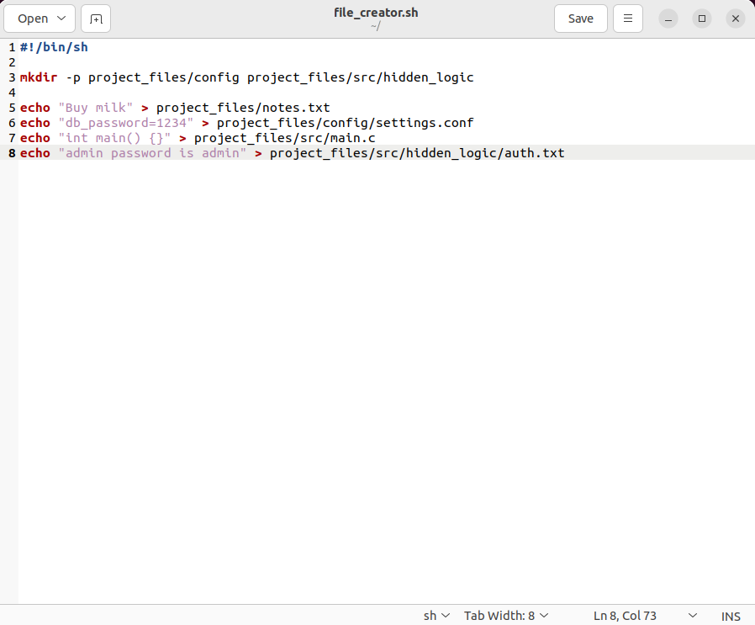
Q2)

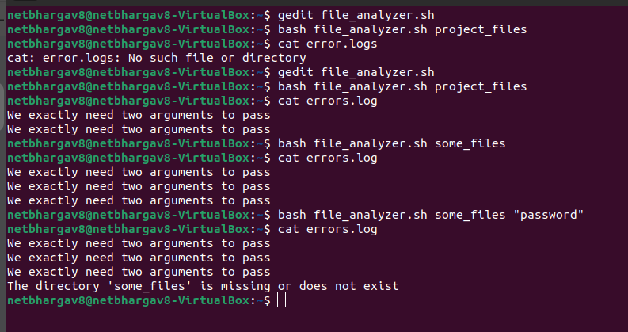
Q3)

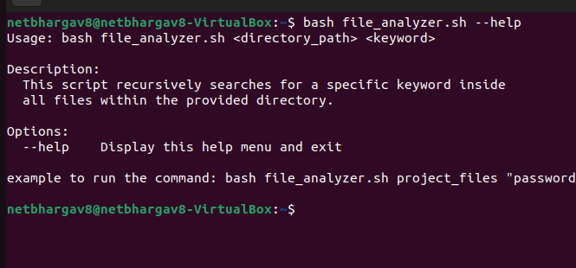
Q4)
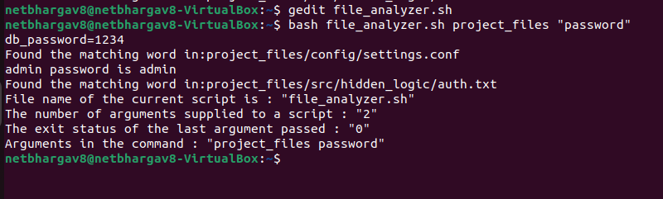

Q5)

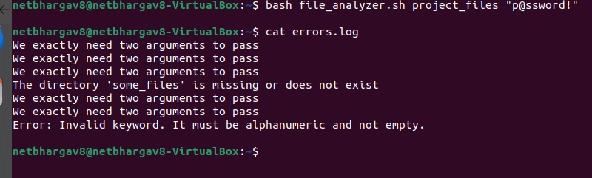
Q6)

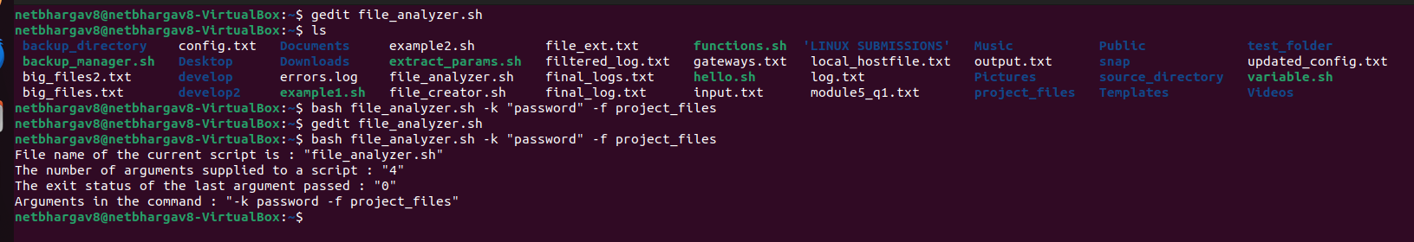
The code:
#!/bin/bash

#q1 recursion_question
search_files(){
local dir="$1"
local word="$2"
for item in "$dir"/*;do
if [ -d "$item" ]; then
search_files "$item" "$word"
elif [ -f "$item" ]; then
if grep "$word" <<< "$(<"$item")";then
echo "Found the matching word in:$item"
fi
fi
done
}

#q3 and q6
if [ "$1" == "--help" ]; then
cat << 'EOF'
Usage: bash file_analyzer.sh [OPTIONS]

Options:
-d <directory> Directory to search
-k <keyword> Keyword to search
-f <file> File to search directly
--help Display this help menu
EOF
exit 0
fi
while getopts "d:k:f:" opt; do
case $opt in
d) directory=$OPTARG ;;
k) keyword=$OPTARG ;;
f) file=$OPTARG ;;
\?)
error_msg="Error: Invalid option provided."
echo "$error_msg"
echo "$error_msg" >> errors.log
exit 1
;;
esac
done

#q4 special parameters
cat << EOF
File name of the current script is : "$0"
The number of arguments supplied to a script : "$#"
The exit status of the last argument passed : "$?"
Arguments in the command : "$@"
EOF

# This command shifts the positional parameters so your script knows getopts is done
shift $((OPTIND -1))

#q2 error_handler and q5 regex

if [ "$#" -ne 2 ];then
error_msg="We exactly need two arguments to pass"
echo "$error_msg" >> errors.log
exit 1
fi
keyword_regex="^[a-zA-Z0-9_]+$"

if ! [[ "$2" =~ $keyword_regex ]]; then
echo "$error_msg" >> errors.log
echo "$error_msg"
exit 1
fi

if [ ! -d "$1" ];then
error_msg_2="The directory '$1' is missing or does not exist"
echo "$error_msg_2" >> errors.log
exit 1
fi

search_files "$1" "$2"

